The Library

CPP-2012.txt has 1 chapters.

CPP-2016.txt has 56 chapters.

NDC-2012.txt has 8 chapters.

NDC-2016.txt has 38 chapters.

NPP-2012.txt has 8 chapters.

NPP-2016.txt has 18 chapters.

**Confusion Matrix**

|  |  |  |  |  |
| --- | --- | --- | --- | --- |
| Confusion Matrx  Actual/Predicted | CPP | NDC | NPP | Error Rate |
| CPP | 0 | 1 | 0 | 1.00 |
| NDC | 0 | 8 | 0 | 0.00 |
| NPP | 0 | 1 | 7 | 0.125 |

Interpretation

**The OOB Error Rate**

OOB estimate of error rate: 11.76%.

Graph 1

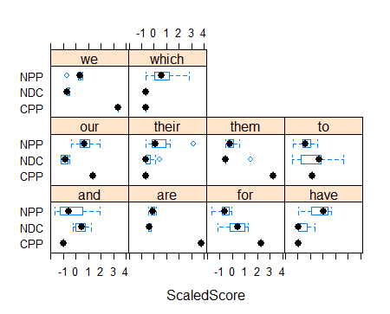

Interpretation of Graph 1

**Guess**

|  |  |  |  |
| --- | --- | --- | --- |
|  | CPP | NDC | NPP |
| CPP | 45 | 0 | 11 |
| NDC | 31 | 0 | 7 |
| NPP | 4 | 0 | 14 |

Interpretation

Graph 2

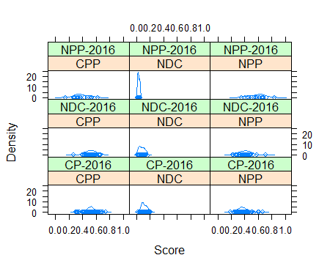

**Interpretation**